Code:
import 'package:flutter/material.dart';
void main() => runApp(MaterialApp(
debugShowCheckedModeBanner: false,
home: Scaffold(
appBar: AppBar(title: Text('Form App')),
body: Padding(
padding: EdgeInsets.all(16),
child: _LoginForm(),
),
),
));
class _LoginForm extends StatefulWidget {
@override
State<_LoginForm> createState() => _LoginFormState();
}
class _LoginFormState extends State<_LoginForm> {
final _key = GlobalKey<FormState>();

Widget buildField(String hint,
{bool obscure = false, TextInputType? type}) =>
Padding(
padding: EdgeInsets.only(bottom: 16),
child: TextFormField(
obscureText: obscure,
keyboardType: type,
decoration: InputDecoration(
hintText: hint,
border:
OutlineInputBorder(borderRadius: BorderRadius.circular(8)),
),
validator: (v) => v!.isEmpty ? 'Enter $hint' : null,
),
);
@override
Widget build(BuildContext context) => Form(
key: _key,
child: Column(
children: [
SizedBox(height: 20),
buildField('Name'),
buildField('Email', type: TextInputType.emailAddress),
buildField('Password', obscure: true),
SizedBox(height: 10),
SizedBox(
width: 150,
height: 45,
child: ElevatedButton(
onPressed: () {
if (_key.currentState!.validate()) {
ScaffoldMessenger.of(context).showSnackBar(
SnackBar(content: Text('Form Submitted')));
}
},
child: Text('Submit'),
),
)
],
),
);
}
Output:
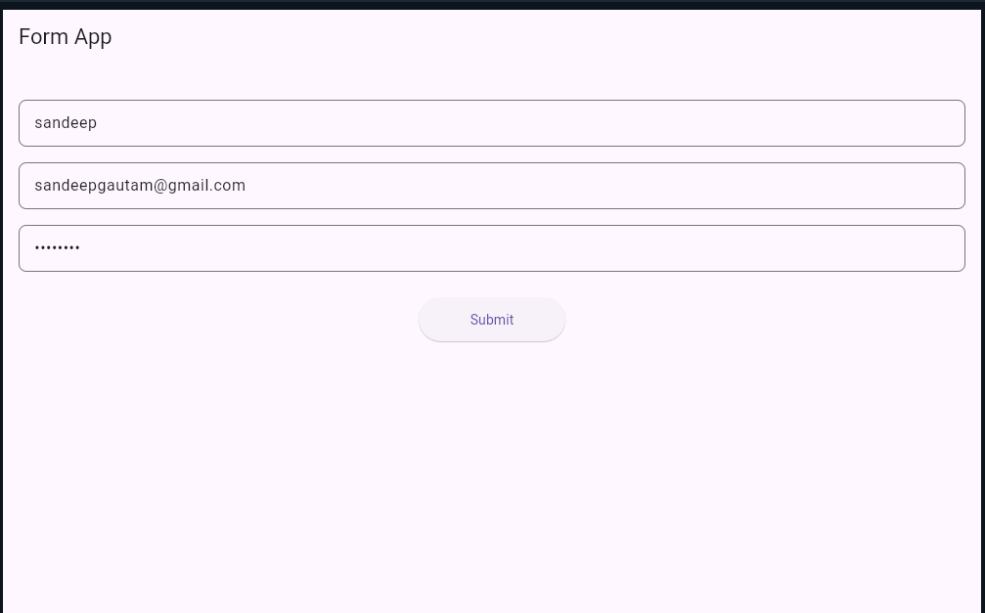
Harshadkolabe0205@gmail.com
HARSHAD

